

*A*

*Project On*

**Online Training Management**

*Presented*

*By,*

Payal Ajit kavitake

**INDEX**

|  |  |  |
| --- | --- | --- |
| **Sr.No** | **Topic** | **Page No** |
| 1 | Introduction And Requirement | 3 |
| 2 | Data Model | 4 |
| 3 | Screenshots | 5 |
| 4 | Custom Pages | 10 |
| 5 | Conslusion | 11 |

**Project Introduction and Requirement**

Online Training Management application that will store all the details of the training from courses offered, trainers, student enrolled, meeting/training information and many more.

In the project,creating objects to store the records and creating various fields to store the values of the records.

And establishing the relationships between various objects and create custom pages using visualforce and the lightning aura component.

Requirements:

Salesforce Environment in that objects, fields, reports and dashboard, visualforce, triggers, apex, lightning aura component etc

**Data Model**

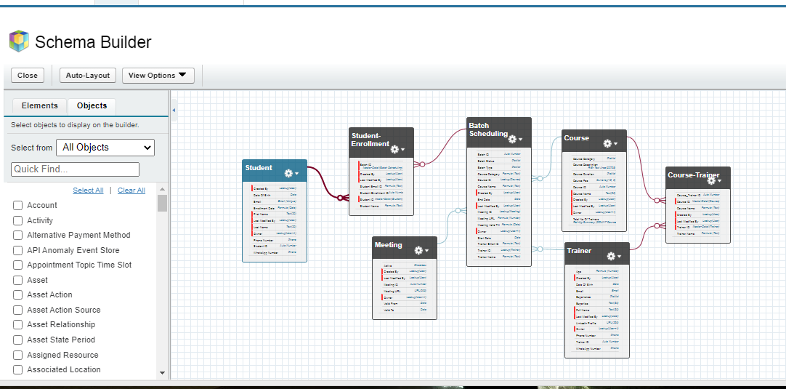

**ScreenShots Of Application**

1. **Home ScreenShot**

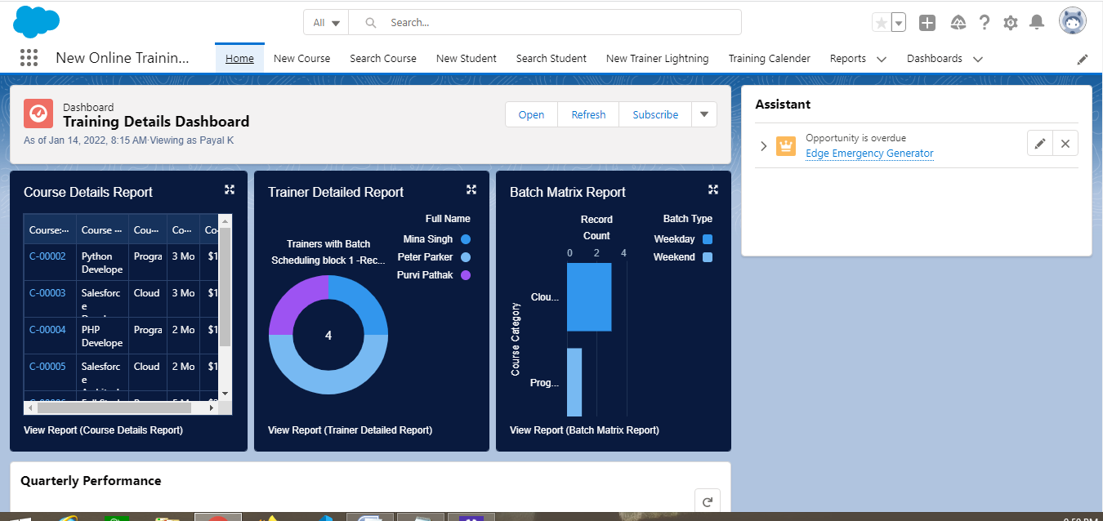

**2.To Add Course**

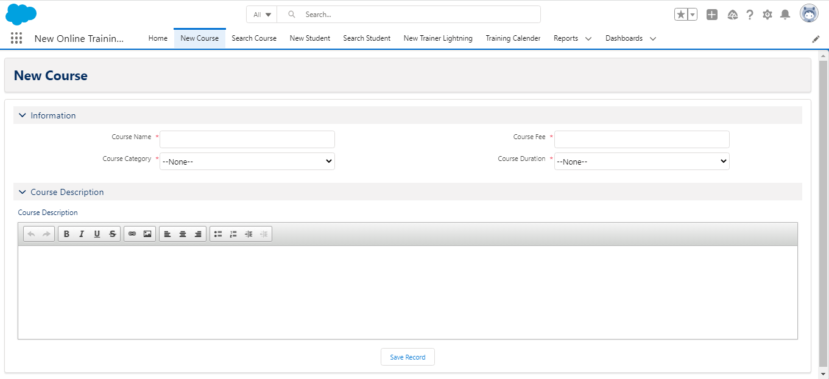

**3.To Search Course**

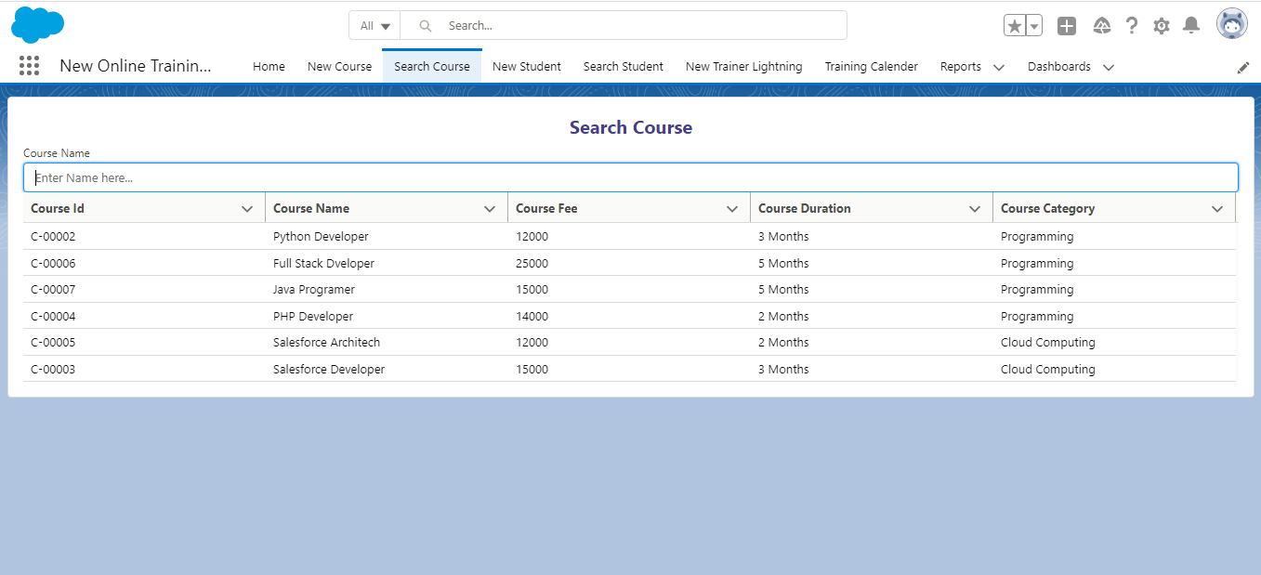

**4.To add New Student**

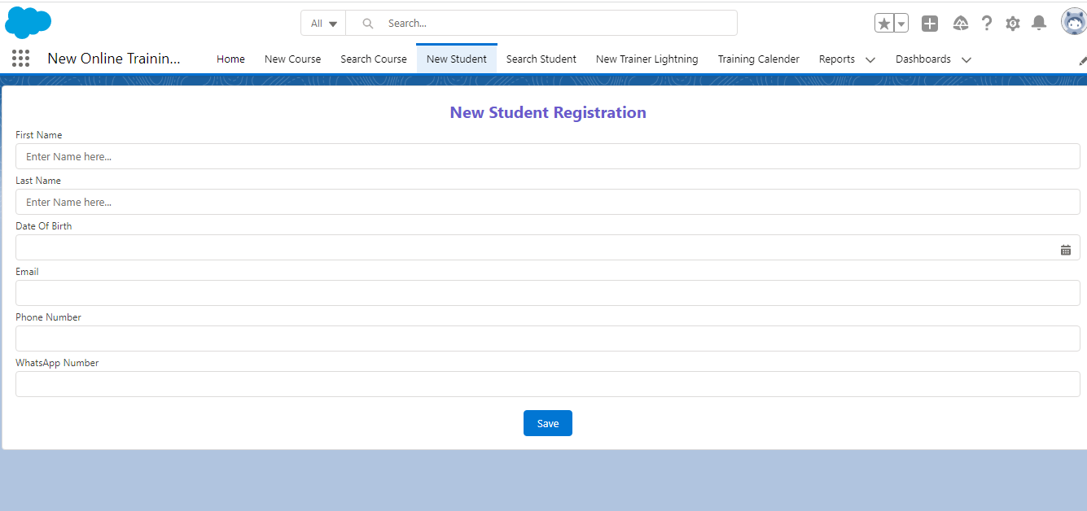

**5.To Search Student**

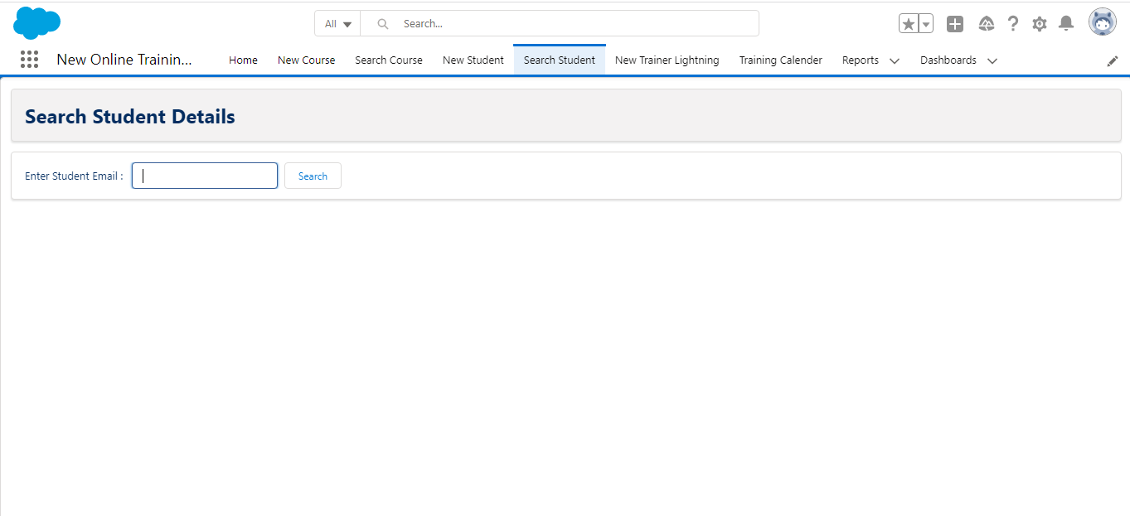

**6.To add New Trainer**

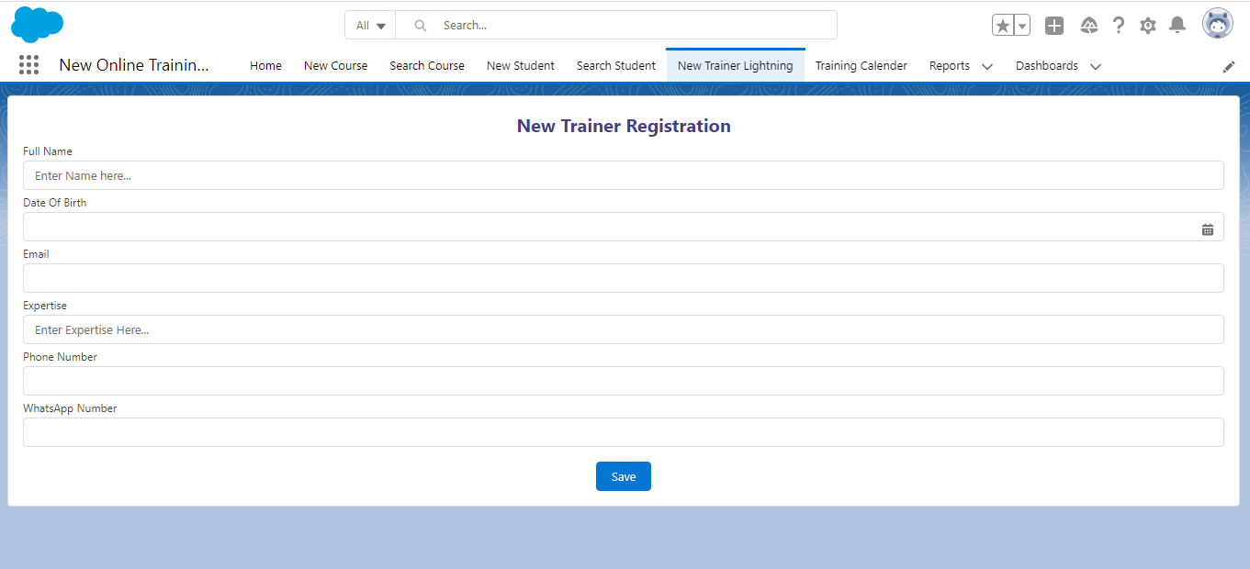

**7.Training Calender**

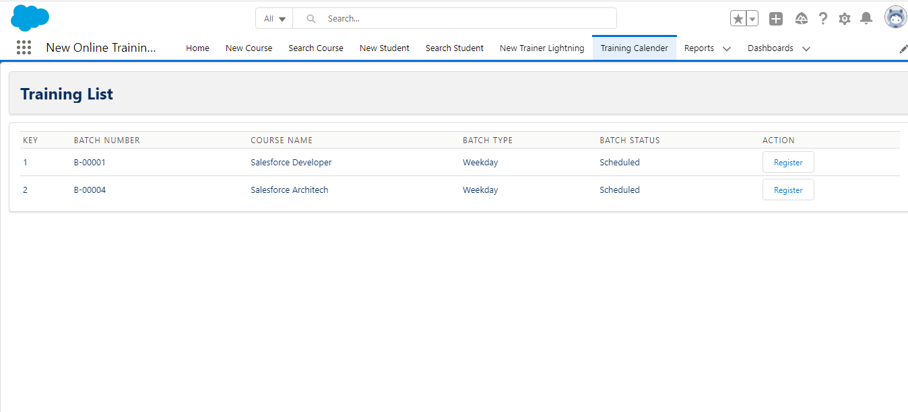

**8.Reports**

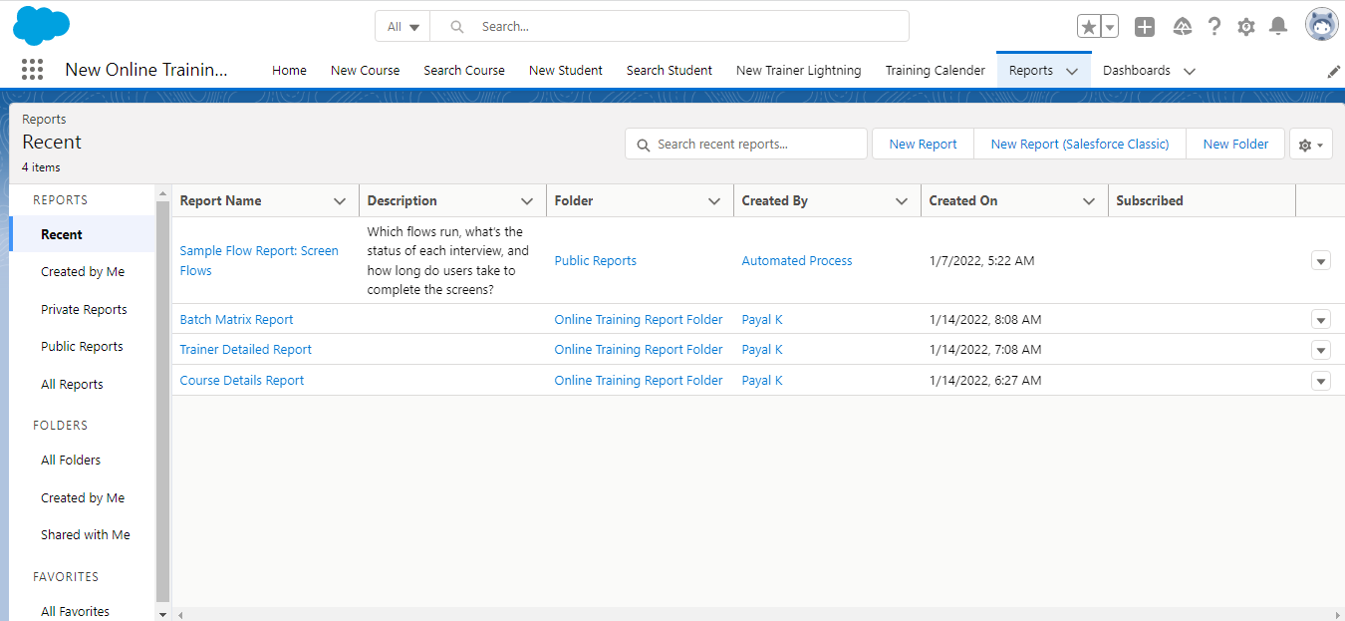

**9.Dashboard**

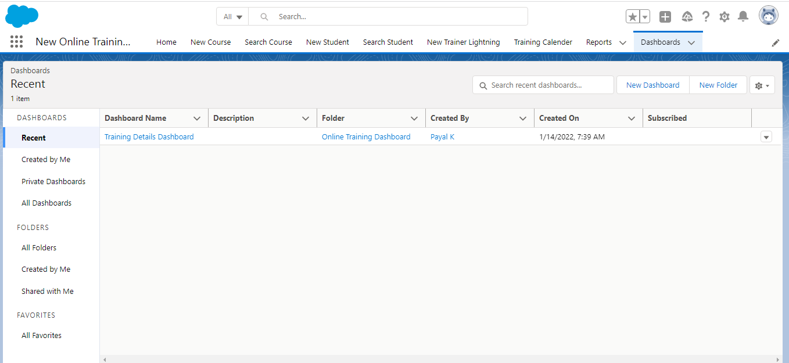

**Custom Pages**

In salesforce we can create cutstom pages in three ways:

1.Visual Force:

Visualforce is the [Markup Language](https://www.tutorialkart.com/salesforce/what-is-saml-security-assertion-markup-language/) (Tag based language) similar to HTML and XML which was developed by Salesforce.com. It contains tags and controllers where tags are also called as Components. Visualforce uses XML like syntax to create front end design pages and it uses APEX as the backend to implement business logic.

2.Lightning Aura Component:

Aura components are the self-contained and reusable units of an app. They represent a reusable section of the UI, and can range in granularity from a single line of text to an entire app. A component can contain other components, as well as HTML, CSS, JavaScript, or any other Web-enabled code. This enables you to build apps with sophisticated UIs.

3.Lightning Component:

The Lightning Component Framework is a UI framework for developing dynamic web apps for mobile and desktop devices. It’s a modern framework for building single-page applications engineered for growth.

**Conclusion:**

By the Online Training Management, I have Conclude that It is very useful for the training institutes for online classes. while creating this I have get problem while creating visual force pages, reports but I have faced that problems very confidently.